Group Members
No | Roll No. | Name | Responsibilities
1 | 2223-4CS-01 | Khun Si Thu | System Architecture, Database Schema, Backend API
2 | 2223-4CS-02 | Aung Myo Thant | Frontend Admin Web Portal, UI/UX Design
3 | 2223-4CS-03 | Kyaw Zin Lwin | Agent Mobile App, System Flow Charts
4 | 2223-4CS-04 | Su Thinzar Win | Customer Mobile App, Use Case Diagrams
5 | 2223-4CS-05 | Thin Thin Yu | Security & Encryption, Testing & QA
6 | 2223-4CS-06 | Phyu Phyu Aung | Software Documentation, Final Report & Presentation

Supervised By
Daw Nan Nu Nu Kyi
Faculty of Information Science
University Of Computer Studies (Hpa-An)

Contents
Chapter (1) Introduction Pages 3
Abstract .................................................... 3
1.1 Introduction ............................................ 3
1.2 Scope ................................................... 4
1.3 Problem Statement ....................................... 4
1.4 Motivation .............................................. 5
1.5 Project Objectives ...................................... 5
1.6 Background Technology ................................... 6
Chapter (2) System Design Pages 7
2.1 Database Schema ......................................... 7
2.2 Use Case Diagram ........................................ 12
2.3 System Flow Diagram ..................................... 15
Chapter (3) Project Implementation Pages 18
Chapter (4) Conclusion and Reference Pages 35
4.1 Conclusion .............................................. 35
REFERENCES .................................................. 36

Chapter (1)

Abstract
The Digital Wallet Management System is a comprehensive, multi-platform financial technology solution designed to provide secure, instant, and reliable digital payment and money transfer services. Developed to modernize financial transactions in Myanmar, particularly supporting the digital ecosystem of Kayin State and Hpa-An region, the system bridges traditional cash-based transactions with modern electronic financial services. The architecture consists of a centralized RESTful API backend built on Laravel PHP and PostgreSQL, a React/Vite web application for system administrators, and mobile applications for Cash-In/Cash-Out agents and retail customers built using React Native and Expo.
The system implements multi-tiered security protocols including phone OTP verification, 6-digit transaction PIN encryption, role-based access control (RBAC), and National ID (NRC) Know-Your-Customer (KYC) verification. Customers can seamlessly perform wallet-to-wallet transfers, scan dynamic merchant QR codes, submit cash-in and cash-out requests at registered agent counters, and execute external e-commerce payments. Agents manage liquidity, process cash deposits/withdrawals, and integrate partner merchant services. System administrators possess full audit capabilities, fee limit configuration, and real-time transaction monitoring. Overall, the Digital Wallet Management System significantly reduces manual cash handling errors, eliminates double-booking or transaction fraud, and accelerates financial inclusion.

1.1 Introduction
In recent years, the rapid growth of mobile penetration and electronic commerce in Myanmar has created an unprecedented demand for reliable, fast, and accessible digital payment solutions. Traditional cash payment methods are often cumbersome, subject to physical security risks, and lack real-time auditability. The Digital Wallet Management System is engineered as a robust financial technology platform that empowers users to manage money digitally, transfer funds instantaneously, and conduct seamless business transactions.
The ecosystem connects three distinct user roles: Customers, Agents, and System Administrators. Customers benefit from an intuitive mobile wallet allowing instant transfers, QR code payments, and balance tracking. Agents act as physical liquidity hubs where users can exchange cash for digital wallet balance (Cash-In) or withdraw digital funds for physical bank notes (Cash-Out). System Administrators operate a centralized web dashboard that oversees system liquidity, approves NRC KYC submissions, sets transfer limits, and manages external payment gateway API integrations. By offering digital recordkeeping and automated transaction logging in a central PostgreSQL database, the platform eliminates paper receipts, speeds up transaction clearing, and fosters digital economic growth.

1.2 Scope
The scope of this project encompasses the design, implementation, deployment, and testing of an end-to-end digital wallet platform comprising four integrated modules:
1. Backend API Service: Developed using Laravel PHP, providing RESTful JSON endpoints, Sanctum token authentication, rate limiting, pin verification, NRC document storage, dynamic transfer fee calculation, and payment gateway webhooks.
2. Admin Web Portal: Built with React, Vite, and Tailwind CSS, enabling system administrators to monitor overall financial analytics, approve or reject customer NRC KYC submissions, manage agent hierarchies, configure transfer fee structures, and manage external merchant API keys.
3. Customer Mobile Application: Developed using React Native and Expo, providing customer sign-up, phone OTP verification, 6-digit PIN setup, instant P2P wallet transfers, dynamic merchant QR code scanning, cash-in/cash-out requests, and NRC document upload.
4. Agent Mobile Application: Developed for financial agents to handle customer deposits and withdrawals, monitor daily float balances, manage partner merchant services, and generate external e-commerce system keys.

1.3 Problem Statement
The financial ecosystem in regional Myanmar, including Hpa-An, continues to face significant challenges due to heavy reliance on physical cash payments and informal money transfer channels. The key problems identified include:
• Inconvenience and High Risk of Cash Transactions: Carrying large amounts of physical cash poses security risks, delays daily commerce, and incurs physical handling expenses for local businesses.
• Lack of Instant P2P Transfer Infrastructure: Local merchants and individual consumers lack an accessible digital payment system to transfer funds instantly without visiting traditional bank branches during business hours.
• Manual Record-Keeping & Operational Bottlenecks: Unregistered cash transfer shops rely on manual paper ledgers, which lead to human errors, untracked accounting discrepancies, and vulnerability to financial fraud.
• Lack of Merchant E-Commerce Payment Gateways: Regional e-commerce businesses lack API integration gateways to accept digital payments automatically from mobile wallet users.

1.4 Motivation of the Project
The primary motivation for developing the Digital Wallet Management System is to drive digital financial inclusion and provide a secure, standardized mobile payment infrastructure. As mobile smartphone adoption reaches unprecedented levels across Myanmar, digital wallets represent the most effective channel for providing financial services to both urban and unbanked rural populations.
Furthermore, financial technology platforms require rigorous security, compliance, and real-time transaction processing. Developing a comprehensive system featuring PIN hashing, phone OTP authentication, NRC document verification, and agent float management addresses real-world business requirements while serving as an exemplary software engineering project.

1.5 Project Objectives
The primary objective of this project is to build an enterprise-grade digital wallet management system that ensures fast, transparent, and highly secure financial transactions. Specific objectives include:
• Implementing multi-factor security using phone OTP validation, 6-digit PIN hashing, and NRC KYC identity verification.
• Delivering instant P2P money transfers, dynamic QR code payments, and agent-assisted Cash-In/Cash-Out services.
• Providing a central administrative portal to monitor system liquidity, approve customer identity verification, and control transaction fees.
• Exposing secure external merchant payment APIs for seamless e-commerce checkout integration.

1.6 Background Technology
The system architecture utilizes modern, scalable open-source technologies tailored for high performance and maintainability:
• Backend Framework: Laravel 11 PHP framework providing robust routing, Eloquent ORM, Sanctum API authentication, middleware pipelines, and secure password/PIN hashing algorithms.
• Database Engine: PostgreSQL relational database storing structured records for users, wallets, transaction ledgers, NRC verification submissions, and external payment sessions.
• Admin Web Portal: React 18, Vite, TypeScript, and Tailwind CSS delivering a responsive, real-time administrative control panel.
• Mobile Applications: React Native with Expo framework, providing cross-platform mobile support for iOS and Android devices, featuring barcode scanning and biometrics.

Chapter (2)

System Design

2.1 Database Schema
The database schema for the Digital Wallet Management System is designed in PostgreSQL using strict relational integrity, foreign key constraints, unique indexing, and automated timestamp tracking. The database consists of 13 core tables storing user profiles, security credentials, wallet balances, transaction ledgers, KYC documents, transfer limit configurations, and external payment gateways.

1. users Table
Stores core user identity, role association, phone number, NRC, and login status.
Column Name | Data Type | Description
id | BIGINT (PK) | Auto-increment primary key
phone_number | VARCHAR(32) | Unique user mobile number for authentication
role_id | BIGINT (FK) | Foreign key referencing roles table
full_name | VARCHAR(255) | Full legal name of the account holder
nrc_number | VARCHAR(64) | Unique National Registration Card number
state_region | VARCHAR(128) | State/Region of residence (e.g. Kayin)
township | VARCHAR(128) | Township of residence (e.g. Hpa-An)
status | VARCHAR(32) | Account status: active, suspended, locked
is_phone_verified | BOOLEAN | Phone OTP verification flag
is_pin_created | BOOLEAN | Transaction PIN creation flag
last_login_at | TIMESTAMP | Timestamp of last user session

2. roles Table
Defines user permissions and access control levels in the platform.
Column Name | Data Type | Description
id | BIGINT (PK) | Primary key
name | VARCHAR(64) | Role name: admin, agent_manager, agent, customer
description | VARCHAR(255) | Detailed description of role permissions

3. wallets Table
Maintains real-time account balances and wallet account numbers.
Column Name | Data Type | Description
id | BIGINT (PK) | Primary key
user_id | BIGINT (FK) | Unique foreign key referencing users table
wallet_number | VARCHAR(64) | Unique 12-digit wallet account number
balance | DECIMAL(15,2) | Current available wallet balance in MMK
status | VARCHAR(32) | Wallet status: active, frozen, closed

4. transactions Table
Immutable ledger recording all money transfers, cash-in/out, and merchant payments.
Column Name | Data Type | Description
id | BIGINT (PK) | Primary key
transaction_number | VARCHAR(64) | Unique reference number (e.g. TX998124)
sender_wallet_id | BIGINT (FK) | Foreign key referencing sender's wallet
receiver_wallet_id | BIGINT (FK) | Foreign key referencing receiver's wallet
receiver_phone | VARCHAR(32) | Destination receiver mobile number
transaction_type | VARCHAR(32) | Type: transfer, cash_in, cash_out, external_payment
amount | DECIMAL(15,2) | Principal transaction amount
fee | DECIMAL(15,2) | System transfer fee charged
agent_id | BIGINT (FK) | Foreign key referencing servicing agent user
status | VARCHAR(32) | Status: pending, completed, failed, refunded
pin_verified | BOOLEAN | Flag indicating successful PIN entry

5. customer_profiles Table
Stores customer-specific KYC status and referral links.
Column Name | Data Type | Description
id | BIGINT (PK) | Primary key
user_id | BIGINT (FK) | Unique foreign key referencing users table
kyc_status | VARCHAR(32) | KYC verification status: pending, approved, rejected
custom_limit_override | DECIMAL(15,2) | Custom daily limit override amount
referral_code | VARCHAR(32) | Unique customer referral code

6. agent_profiles Table
Contains financial agent details, shop location, and manager assignments.
Column Name | Data Type | Description
id | BIGINT (PK) | Primary key
user_id | BIGINT (FK) | Foreign key referencing users table
agent_code | VARCHAR(32) | Unique agent identifier (e.g. AGT-101)
shop_name | VARCHAR(255) | Registered agent shop or business name
shop_address | TEXT | Physical shop address in township
created_by_manager_id | BIGINT (FK) | Foreign key referencing parent agent manager

7. agent_manager_profiles Table
Tracks manager codes and hierarchy for overseeing regional agent networks.
Column Name | Data Type | Description
id | BIGINT (PK) | Primary key
user_id | BIGINT (FK) | Foreign key referencing users table
manager_code | VARCHAR(32) | Unique manager code (e.g. MGR-001)

8. pins Table
Stores encrypted 6-digit transaction PIN hashes and brute-force lock parameters.
Column Name | Data Type | Description
id | BIGINT (PK) | Primary key
user_id | BIGINT (FK) | Foreign key referencing users table
pin_hash | VARCHAR(255) | Bcrypt hashed 6-digit transaction PIN
failed_attempts | INT | Counter for consecutive incorrect PIN entries
is_locked | BOOLEAN | Security lockout flag after max attempts

9. otp_verifications Table
Manages temporary SMS OTP codes and expiration timestamps.
Column Name | Data Type | Description
id | BIGINT (PK) | Primary key
phone_number | VARCHAR(32) | Destination phone number
otp_code | VARCHAR(16) | 6-digit temporary verification code
expires_at | TIMESTAMP | OTP code expiration timestamp

10. qr_codes Table
Generates dynamic and static QR codes for payment scanning.
Column Name | Data Type | Description
id | BIGINT (PK) | Primary key
user_id | BIGINT (FK) | Foreign key referencing QR owner
wallet_id | BIGINT (FK) | Foreign key referencing linked wallet
qr_code_value | VARCHAR(255) | Unique encoded string representation
amount | DECIMAL(15,2) | Pre-filled payment amount (optional)
is_active | BOOLEAN | QR code validity status

11. nrc_verifications Table
Manages NRC document verification submissions and admin review.
Column Name | Data Type | Description
id | BIGINT (PK) | Primary key
user_id | BIGINT (FK) | Foreign key referencing customer
status | VARCHAR(32) | Review status: pending, approved, rejected
rejection_reason | TEXT | Admin feedback note if rejected
verified_by | BIGINT (FK) | Foreign key referencing approving admin
verified_at | TIMESTAMP | Timestamp of admin review action

12. transfer_settings Table
Configures system-wide transfer fee percentages and daily limits.
Column Name | Data Type | Description
id | BIGINT (PK) | Primary key
daily_transfer_limit | DECIMAL(15,2) | Default maximum daily transfer amount
fee_percentage | DECIMAL(5,2) | Percentage fee charged per transfer
min_fixed_fee | DECIMAL(15,2) | Minimum fixed fee threshold

13. external_systems Table
Stores e-commerce merchant system links and secret API keys.
Column Name | Data Type | Description
id | BIGINT (PK) | Primary key
name | VARCHAR(255) | Merchant business or system name
user_id | BIGINT (FK) | Foreign key referencing merchant agent/user
api_key_hash | VARCHAR(255) | Hashed secret API key for gateway auth
api_key_prefix | VARCHAR(12) | Public API key prefix (e.g. ext_live_9a8f)
system_link | VARCHAR(255) | Merchant website or redirect URL
status | VARCHAR(32) | API status: active, disabled

2.2 Use Case Diagram

Admin Use Case
The System Administrator possesses administrative privileges over all customer accounts, financial agents, identity verification requests, transfer fee settings, and external merchant API integrations.
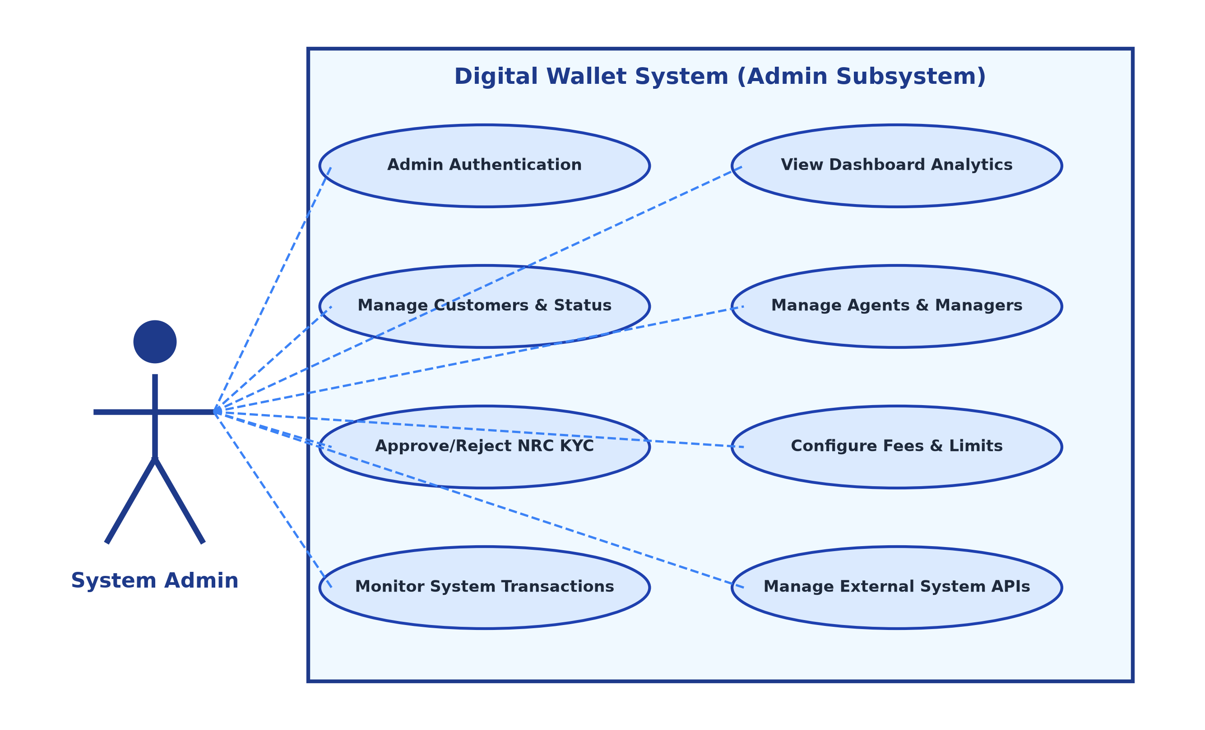
Figure(2.1): Use Case Diagram for Admin

Customer and Agent Use Cases
Customers interact with the wallet to perform authentication, P2P transfers, QR payments, Cash-In/Out requests, and NRC document uploads. Agents process deposits, withdrawals, and merchant integrations.
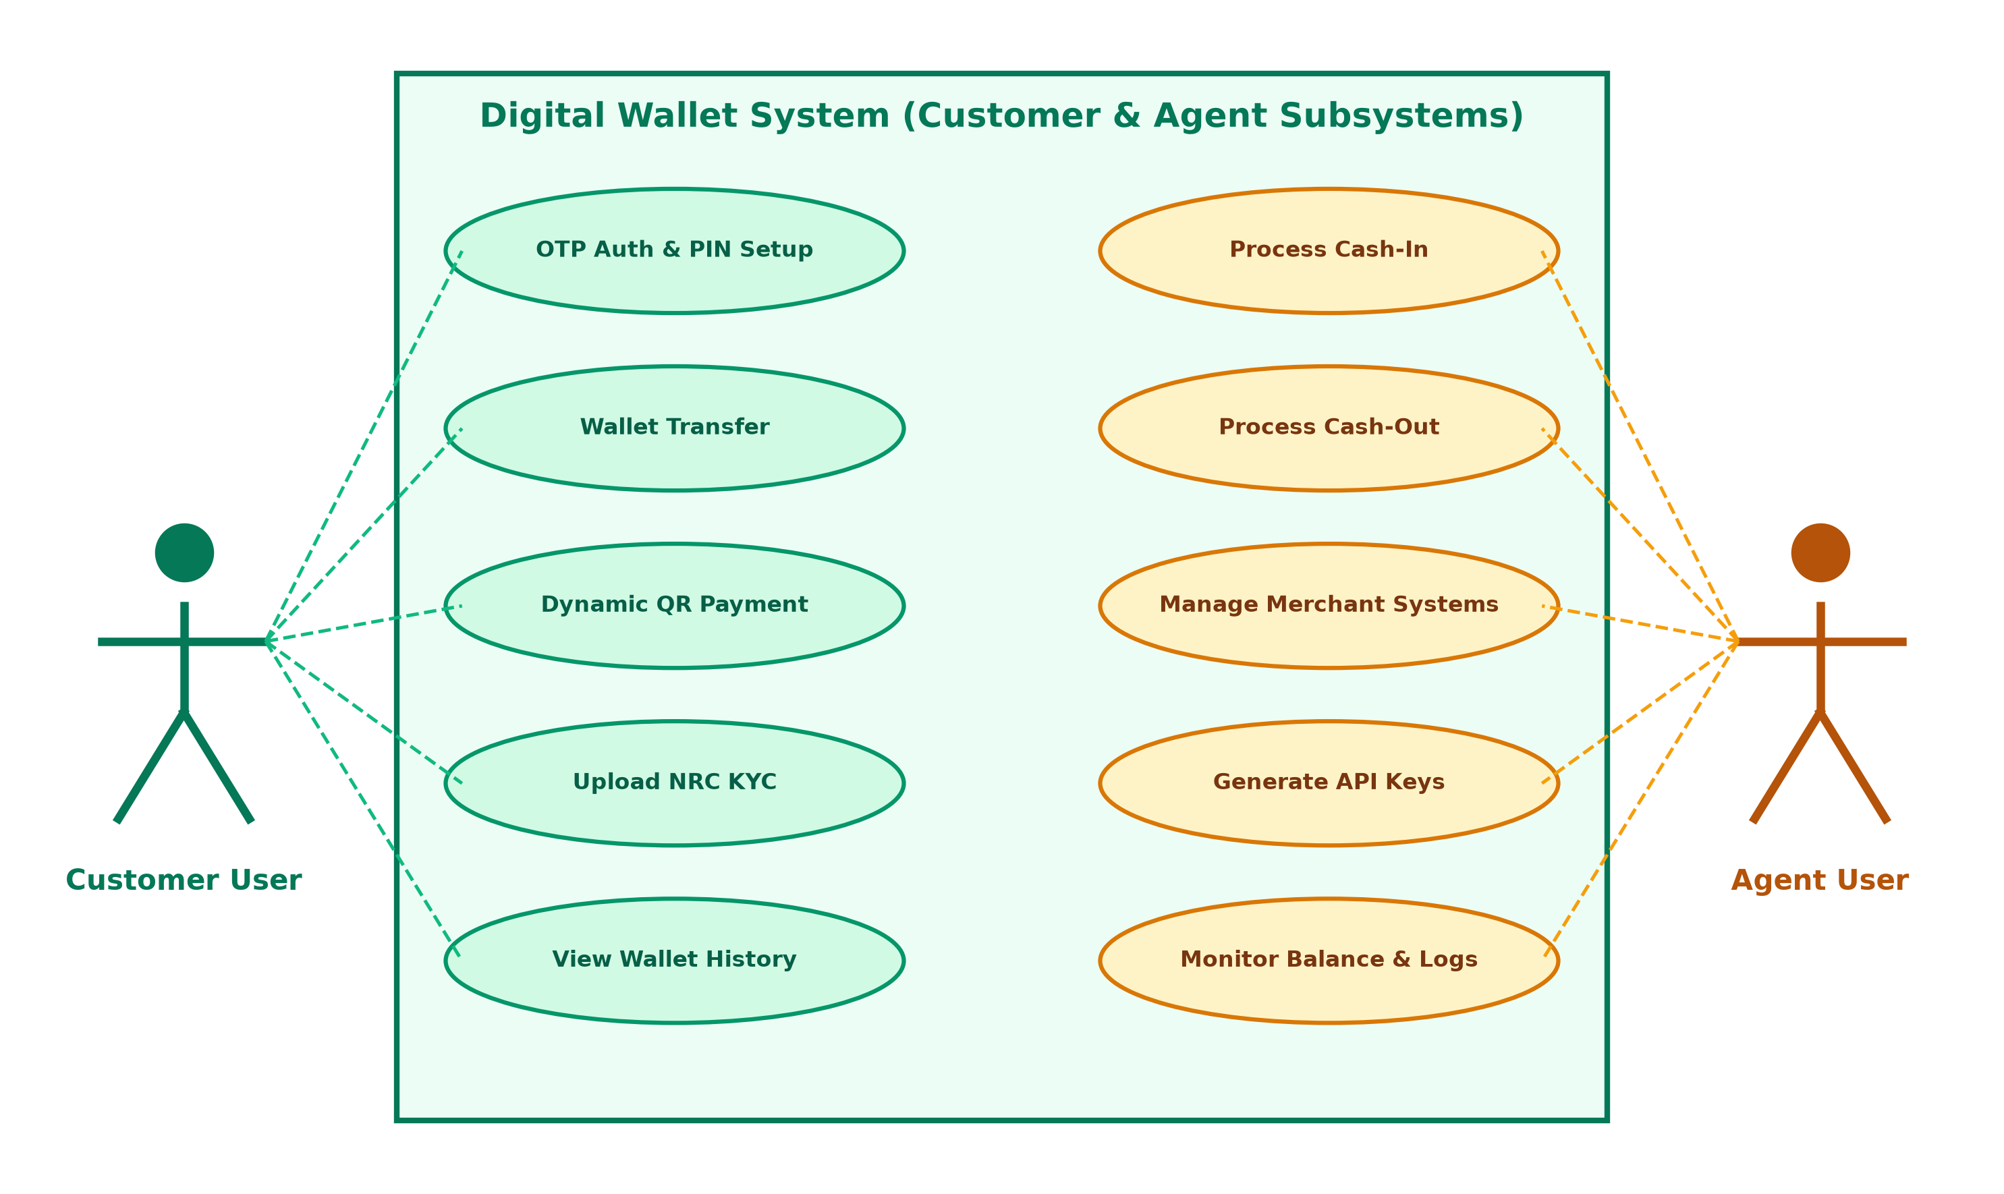
Figure(2.2): Use Case Diagram for Customer and Agent

2.3 System Flow Diagram
The system flow diagrams illustrate operational workflows across guest registration, customer money transfers, and administrative management.

Guest User Registration Flow
New users enter their phone number, receive a 6-digit OTP via SMS, create a 6-digit transaction PIN, and upload NRC identification documents.
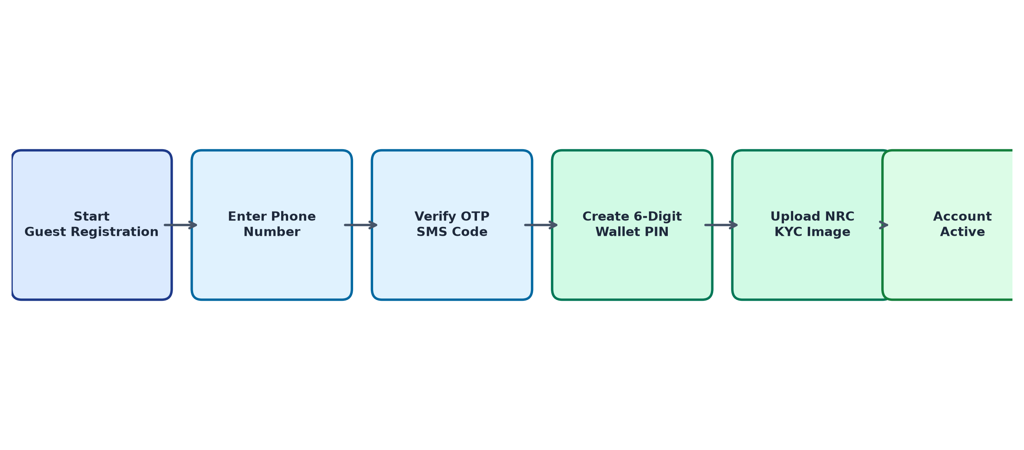
Figure(2.3): System Flow Diagram For Guest User

Logged-In Customer Flow
Authenticated customers log in with their phone and PIN, view real-time wallet balances, execute transfers or QR payments, and receive digital receipts.
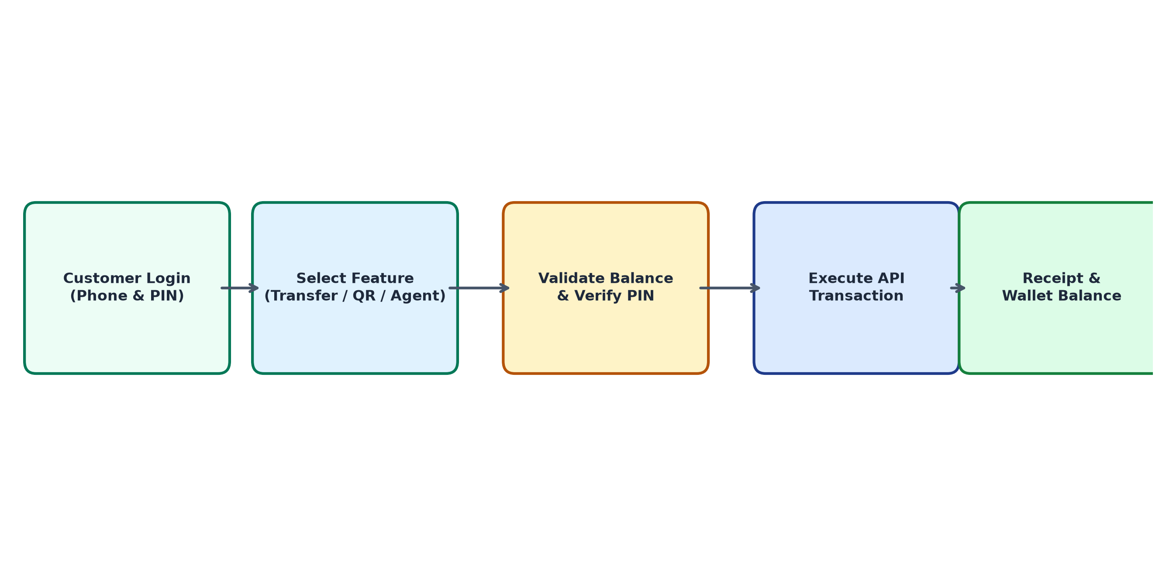
Figure(2.4): System Flow Diagram For Logged-in Customer User

Admin Management Flow
Administrators log into the web control center to monitor dashboard analytics, approve or reject NRC KYC submissions, manage agent hierarchies, and configure transaction limits.
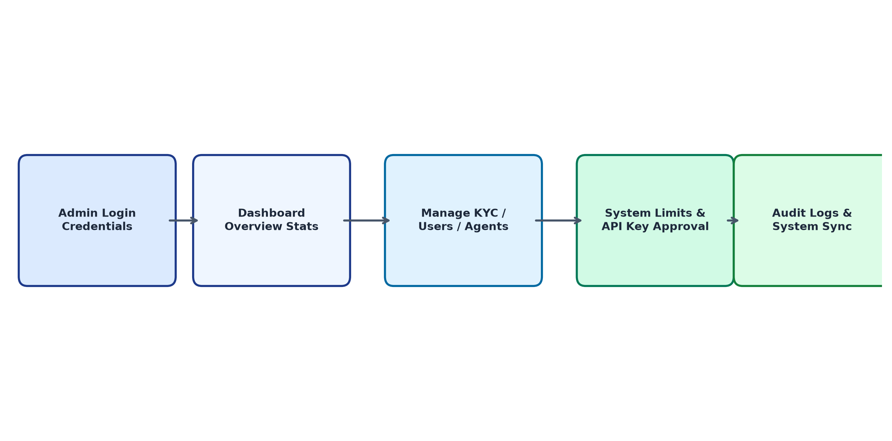
Figure(2.5): System Flow Diagram For Admin and Agent

Chapter (3)

Project Implementation
In this chapter, the implementation details, user interface screens, and functional features of the Digital Wallet Management System are described across the Admin Web Portal, Customer Mobile Application, and Agent Mobile Application.

Admin Sign in Page
In Figure(3.1), administrators access the system by entering their authorized email credentials and password. The authentication endpoint issues a secure Sanctum bearer token and enforces rate limiting to prevent unauthorized access.
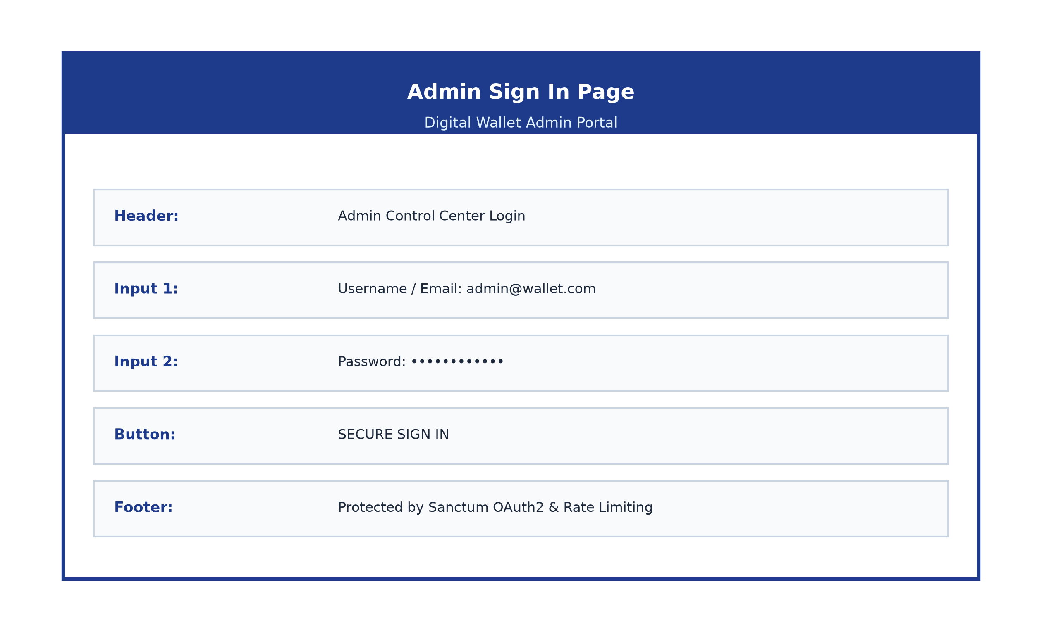
Figure(3.1): Admin Sign in Page

Admin Dashboard Page
In Figure(3.2), administrators view high-level system metrics, including total registered users, active wallet counts, daily transaction volume in MMK, pending KYC review counts, and overall API service health.
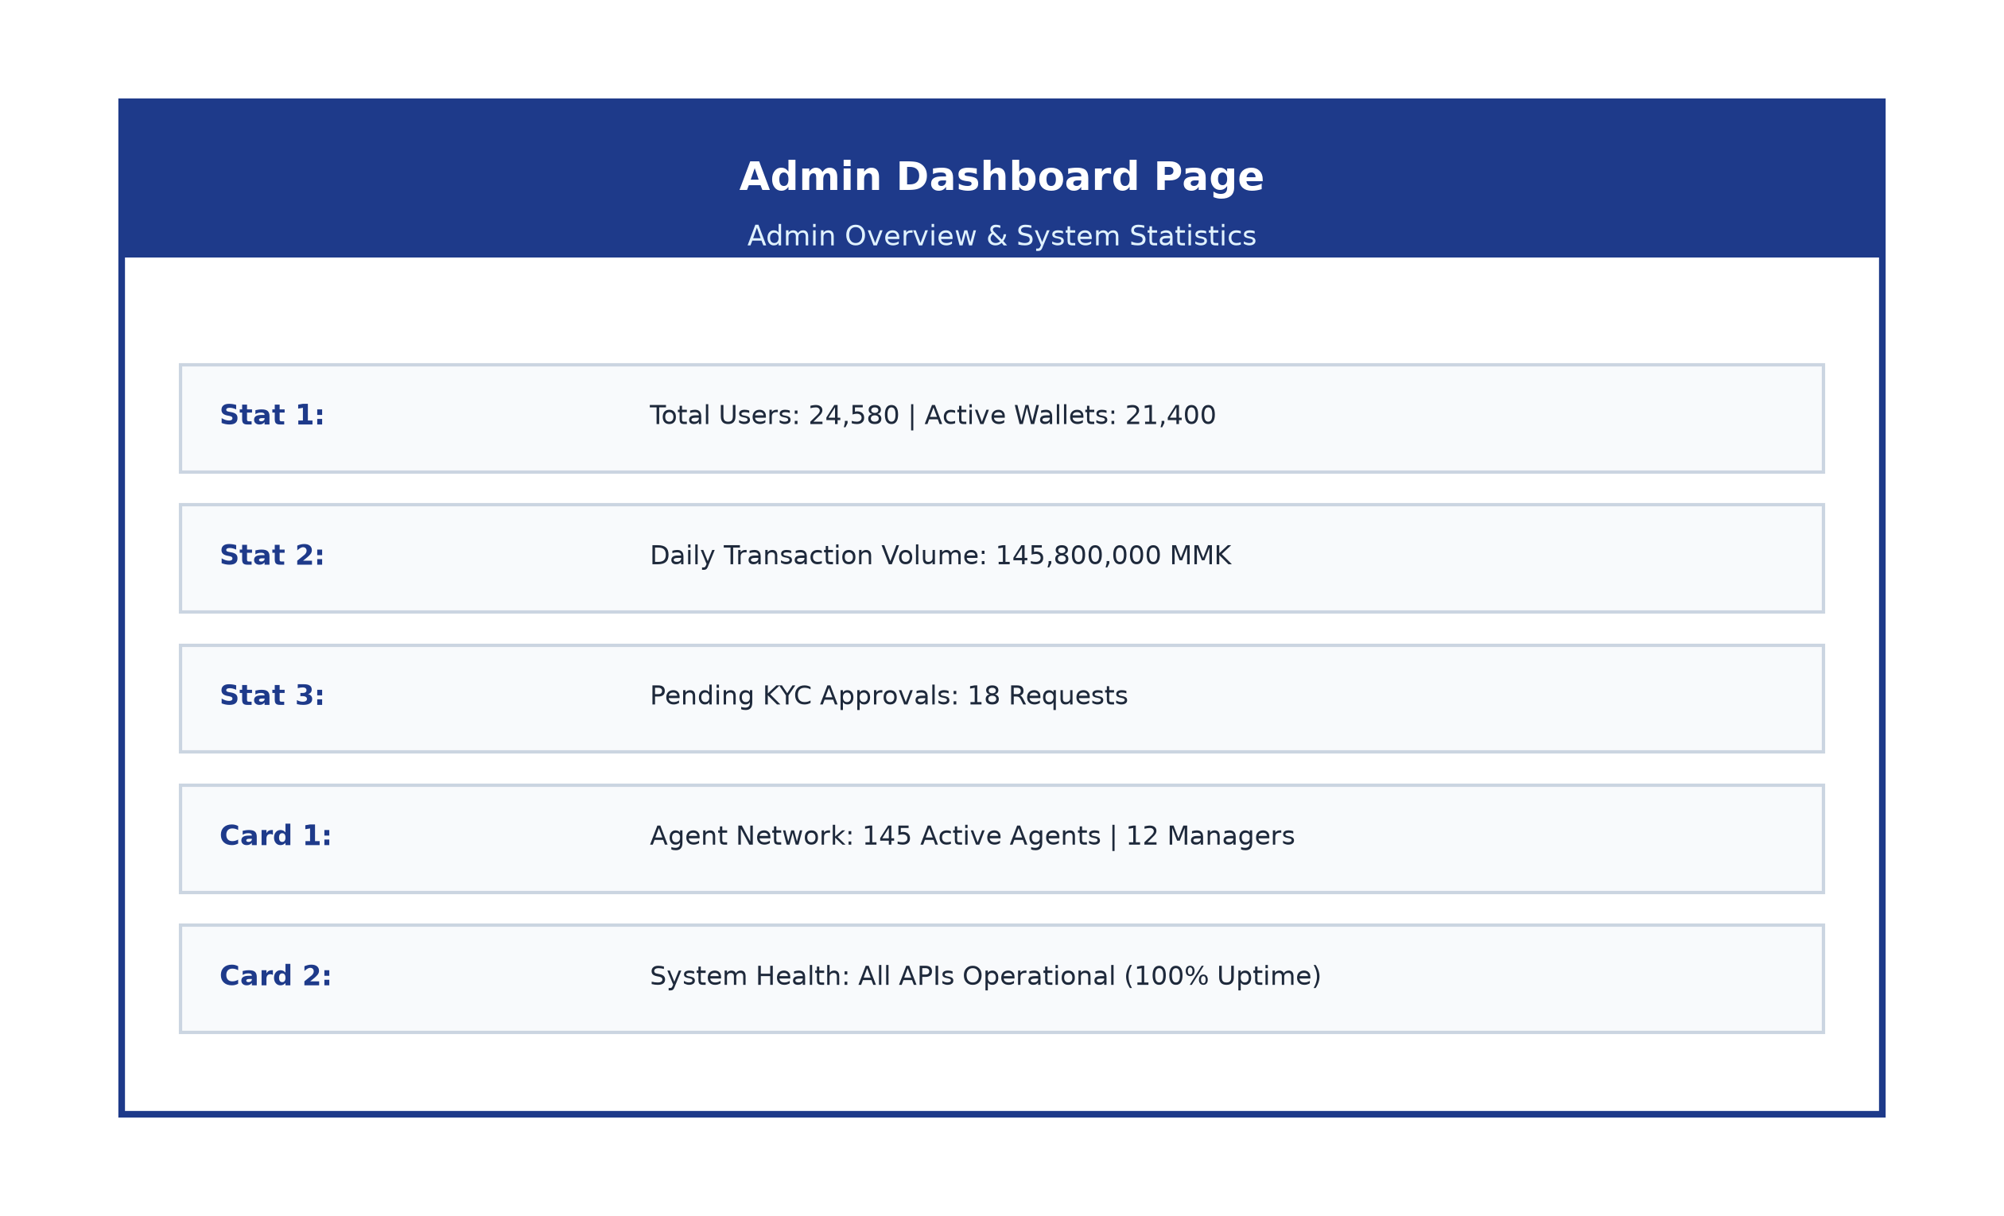
Figure(3.2): Admin Dashboard Page

Manage Customers Page
In Figure(3.3), administrators manage customer account records. The page provides search and filter capabilities, real-time wallet balance displays, account status toggle buttons (active/suspended), and customer record export functionality.
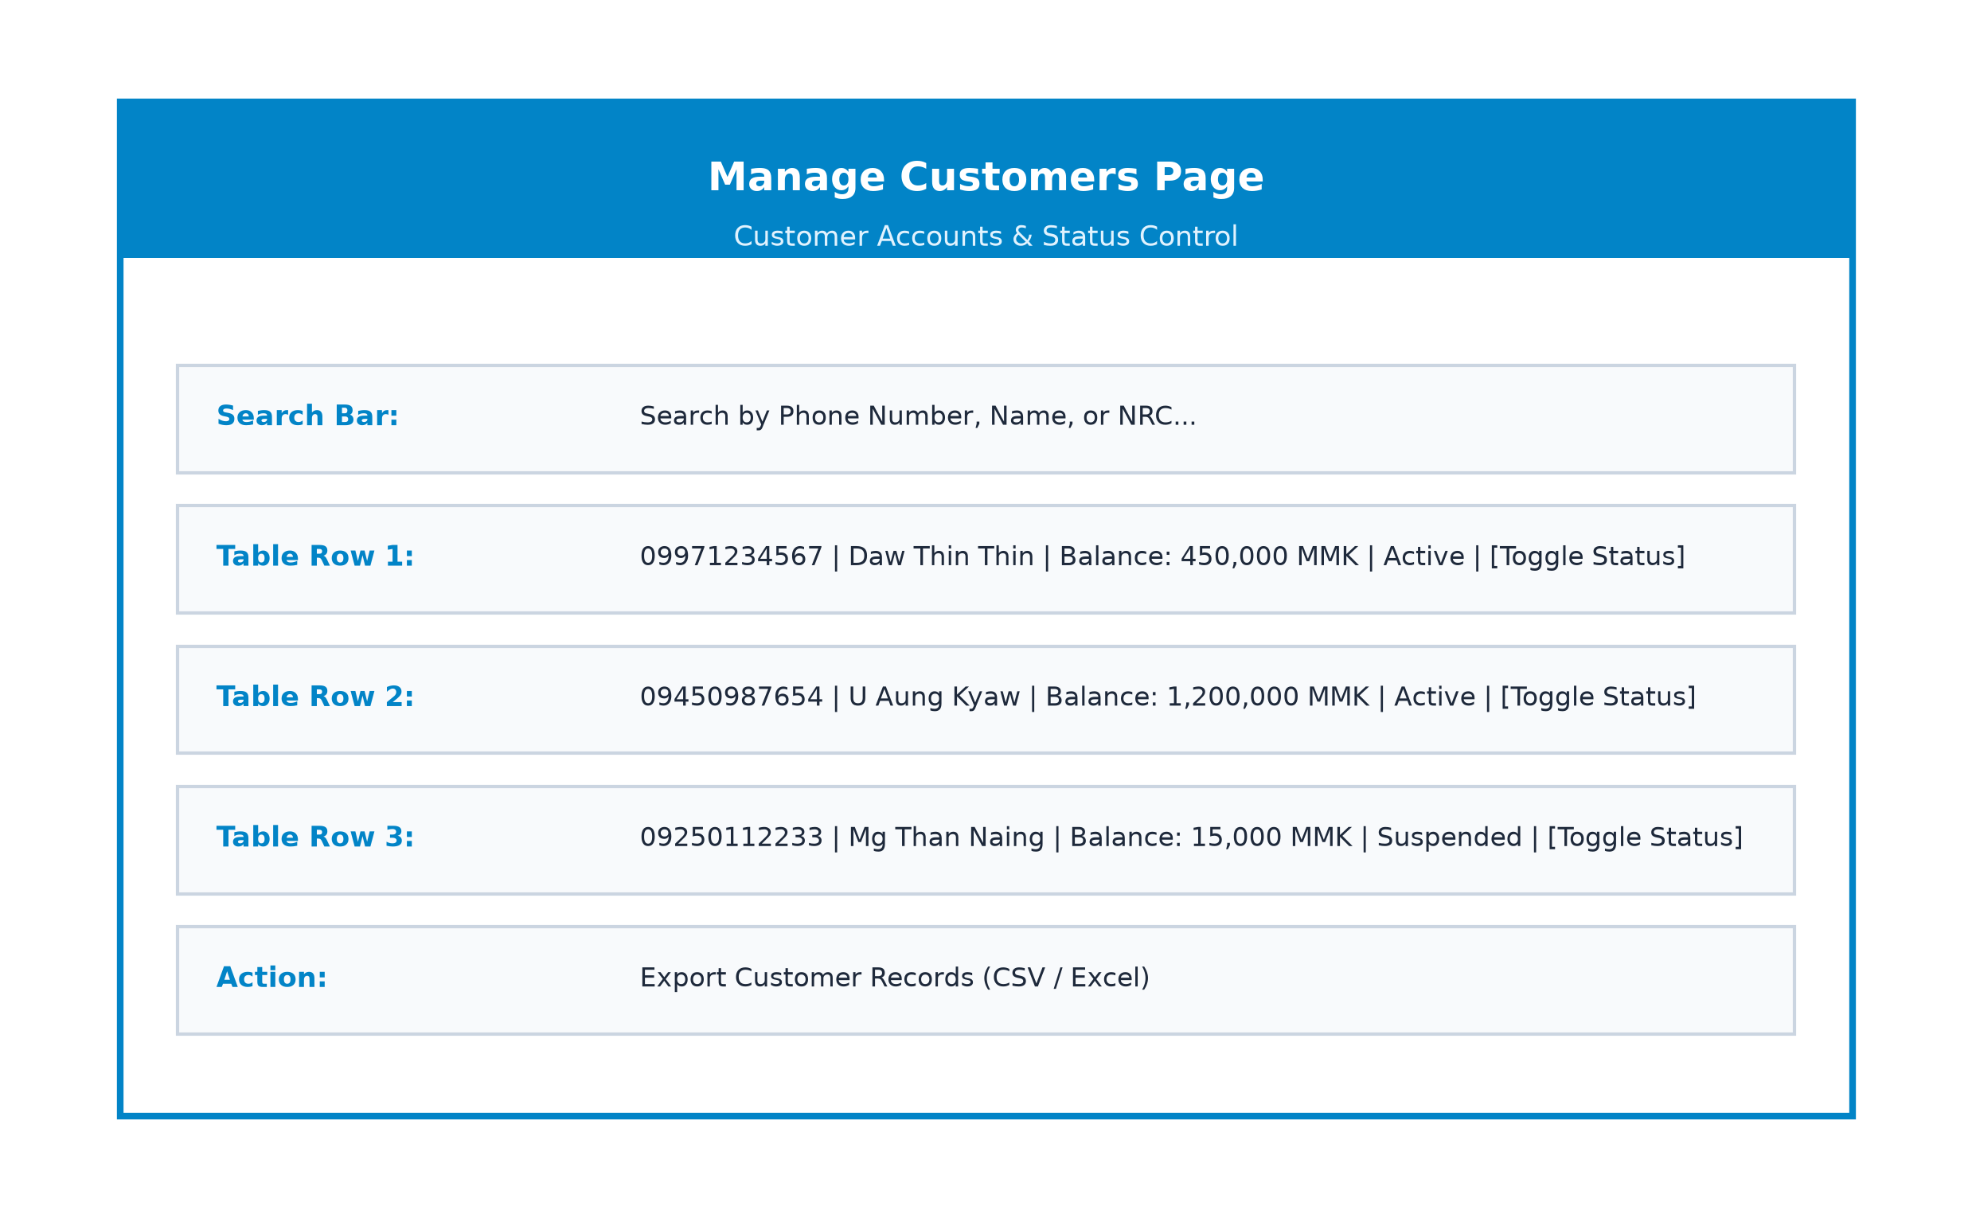
Figure(3.3): Manage Customers Page

Manage Agents & Agent Managers Page
In Figure(3.4), administrators oversee the multi-tiered agent network. They can create agent managers, assign financial agents under specific managers, monitor shop addresses, and toggle operational agent status.
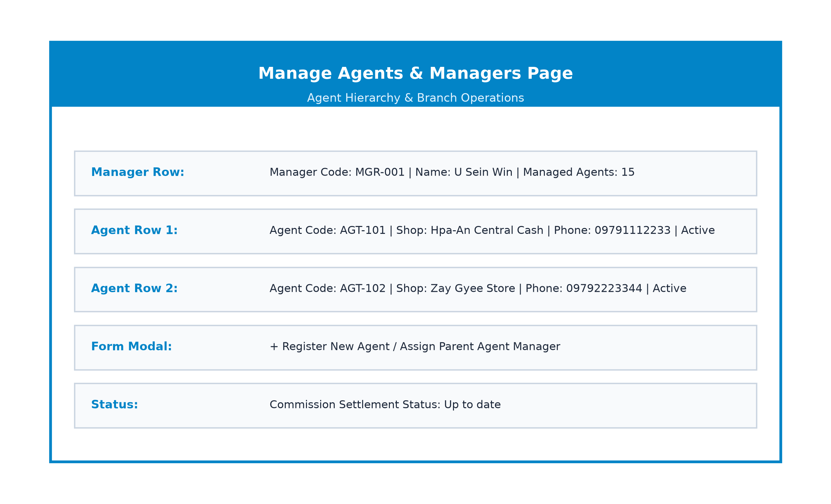
Figure(3.4): Manage Agents & Agent Managers Page

NRC KYC Verification Approval Page
In Figure(3.5), administrators review customer identity verification submissions. Administrators can inspect front and back NRC photos, verify state/township details, approve verification requests, or reject them with specific feedback reasons.
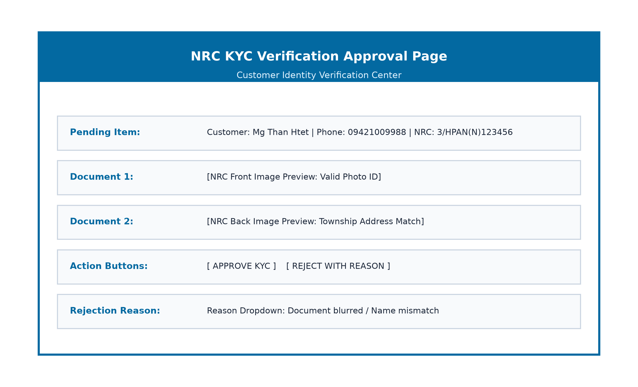
Figure(3.5): NRC KYC Verification Approval Page

Transaction Monitoring Page
In Figure(3.6), administrators monitor system-wide transaction ledgers in real time. Transactions can be filtered by date, type (transfer, cash-in, cash-out, external payment), and status. Total collected fee summaries are automatically calculated.
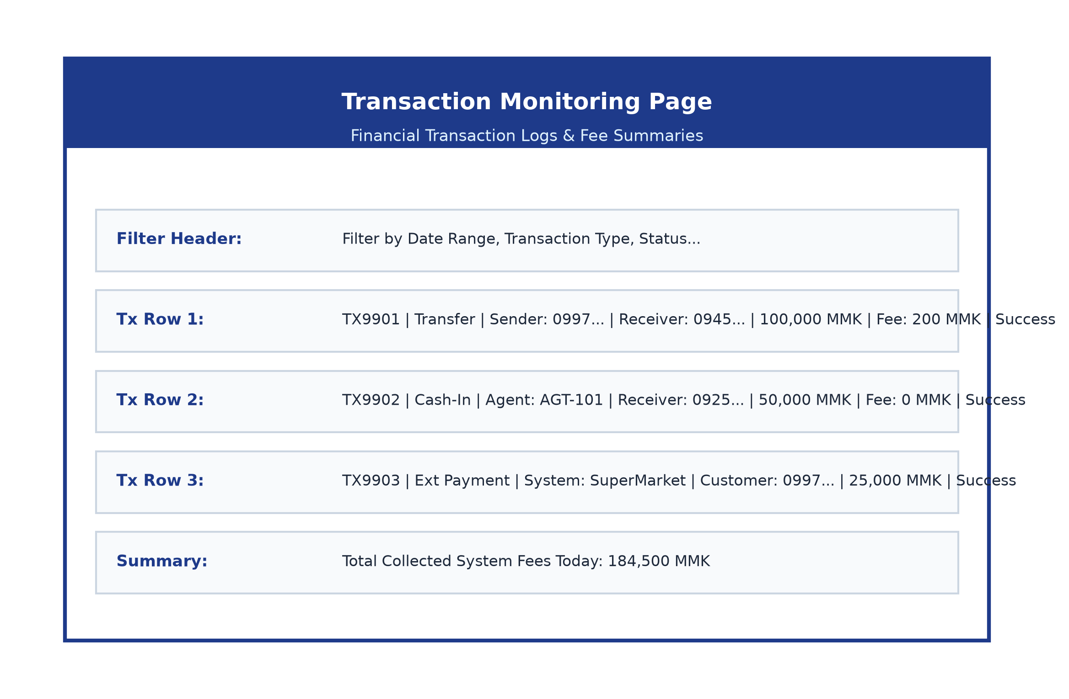
Figure(3.6): Transaction Monitoring Page

Transfer Settings & Limit Page
In Figure(3.7), administrators configure global transaction fee policies, including default daily transfer limits, percentage fees, minimum fixed fees, and individual VIP custom limit overrides.
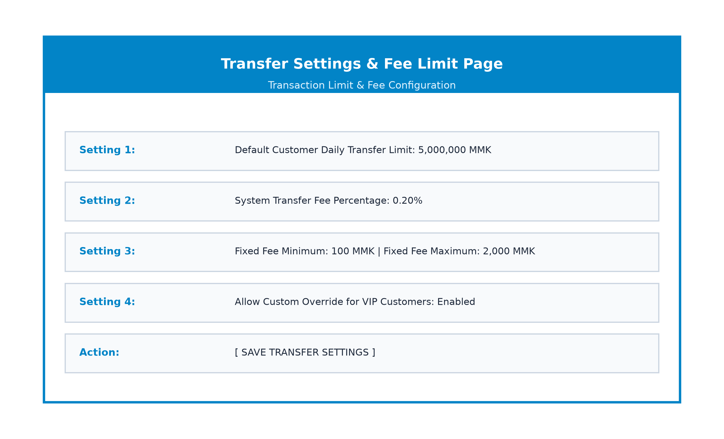
Figure(3.7): Transfer Settings & Limit Page

Manage External Systems Page
In Figure(3.8), administrators oversee partner e-commerce merchant integrations. They can view linked merchant account wallets, inspect public API key prefixes, generate new secret API keys, and toggle merchant API access status.
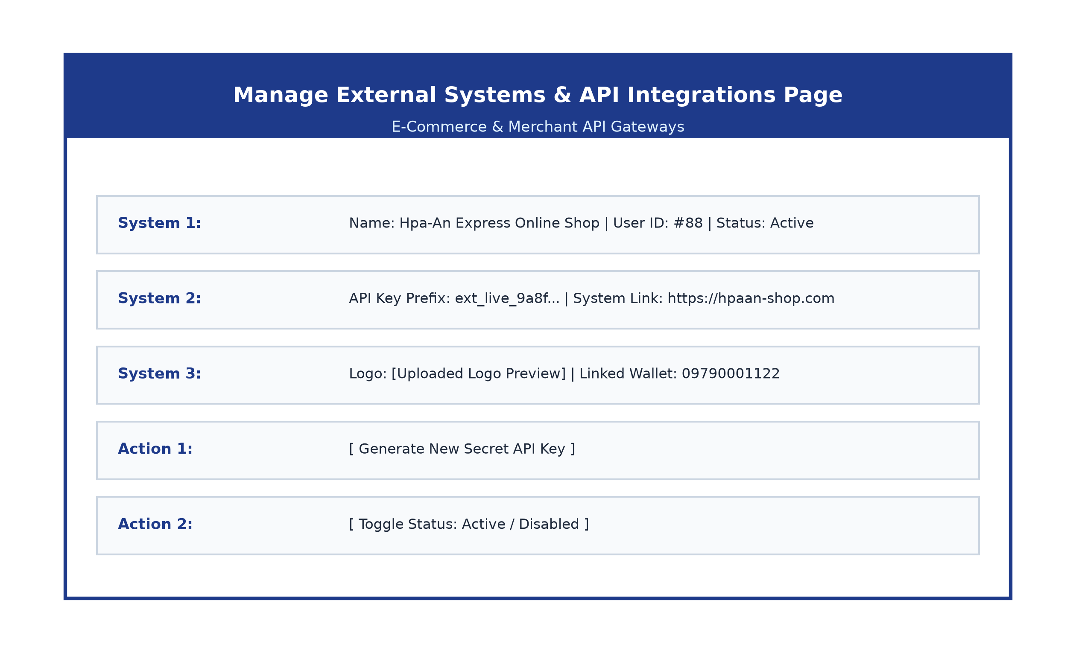
Figure(3.8): Manage External Systems Page

Customer Registration & OTP Page
In Figure(3.9), new customer users initiate account registration by entering their mobile phone number. The system dispatches a 6-digit SMS OTP code, which the user enters to verify phone ownership.
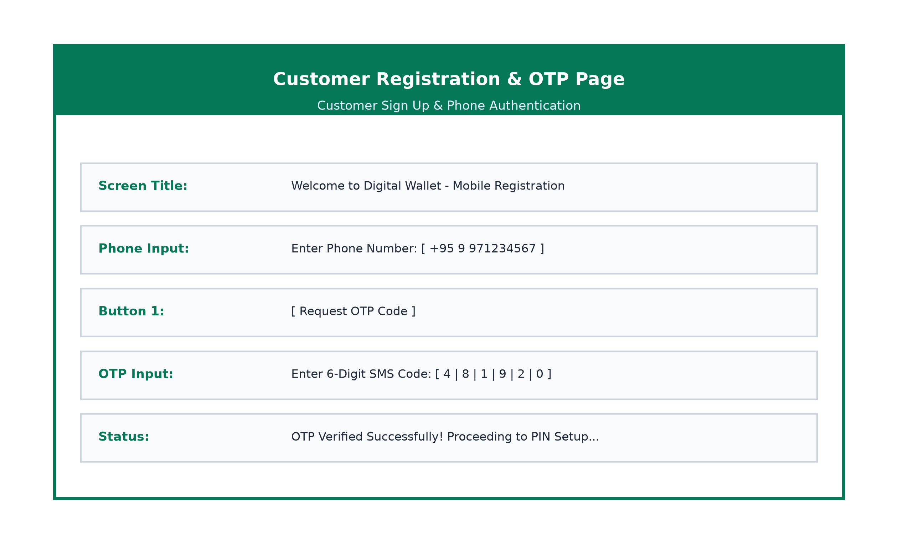
Figure(3.9): Customer Registration & OTP Page

Customer PIN Setup Page
In Figure(3.10), after phone verification, customers create a confidential 6-digit transaction PIN. The PIN is securely hashed using Bcrypt before being stored in the database.
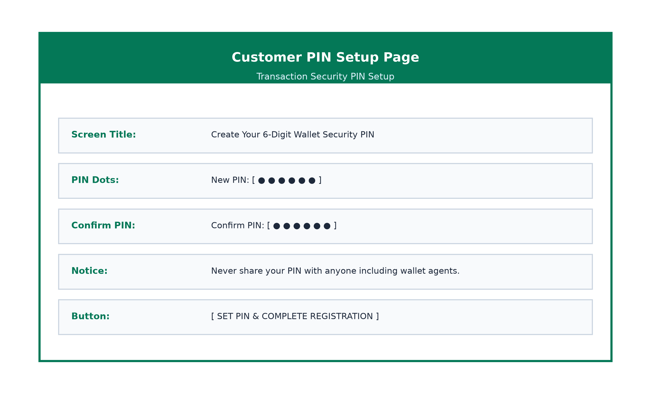
Figure(3.10): Customer PIN Setup Page

Customer Home Dashboard Page
In Figure(3.11), customers access their primary wallet dashboard. The screen displays their current balance in MMK, quick action buttons (Transfer, QR Pay, Cash In, Cash Out), and recent transaction history cards.
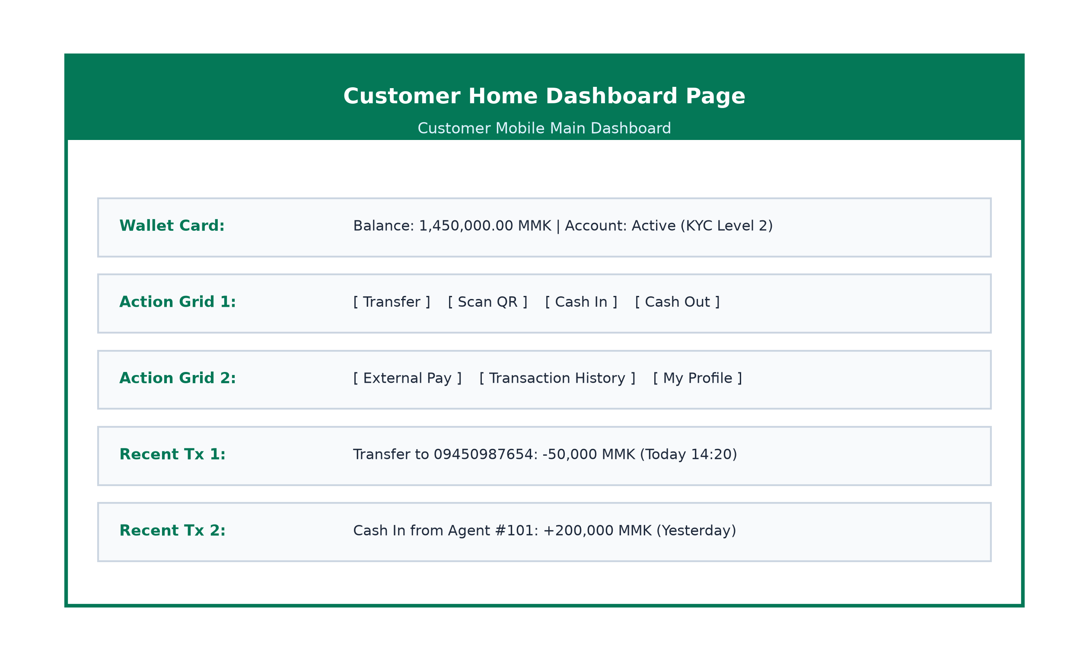
Figure(3.11): Customer Home Dashboard Page

Customer Wallet Transfer Page
In Figure(3.12), customers initiate instant P2P money transfers. Entering a recipient phone number automatically resolves and displays the recipient's verified legal name before prompt verification of the sender's 6-digit PIN.
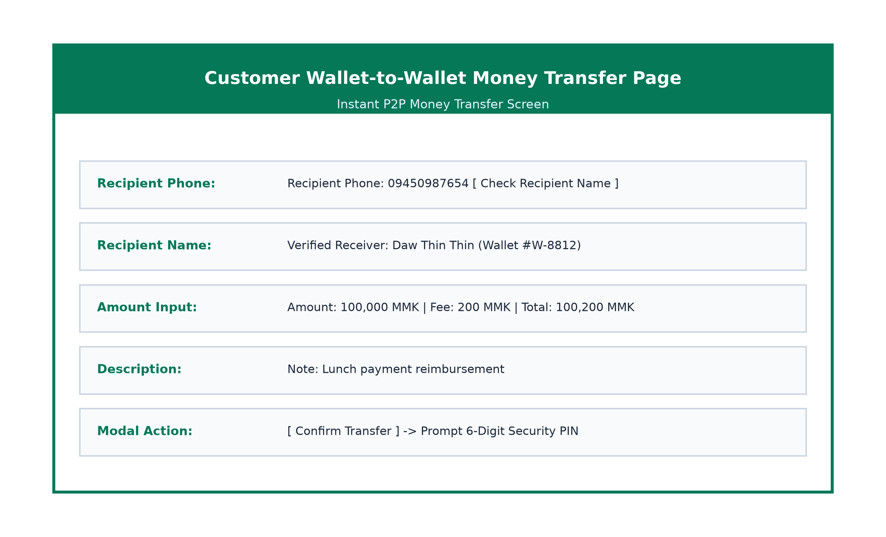
Figure(3.12): Customer Wallet Transfer Page

Customer QR Code Payment Page
In Figure(3.13), customers scan merchant or peer QR codes using their mobile camera. The app parses the encoded wallet ID and amount, prompting PIN confirmation to complete instant QR payments.
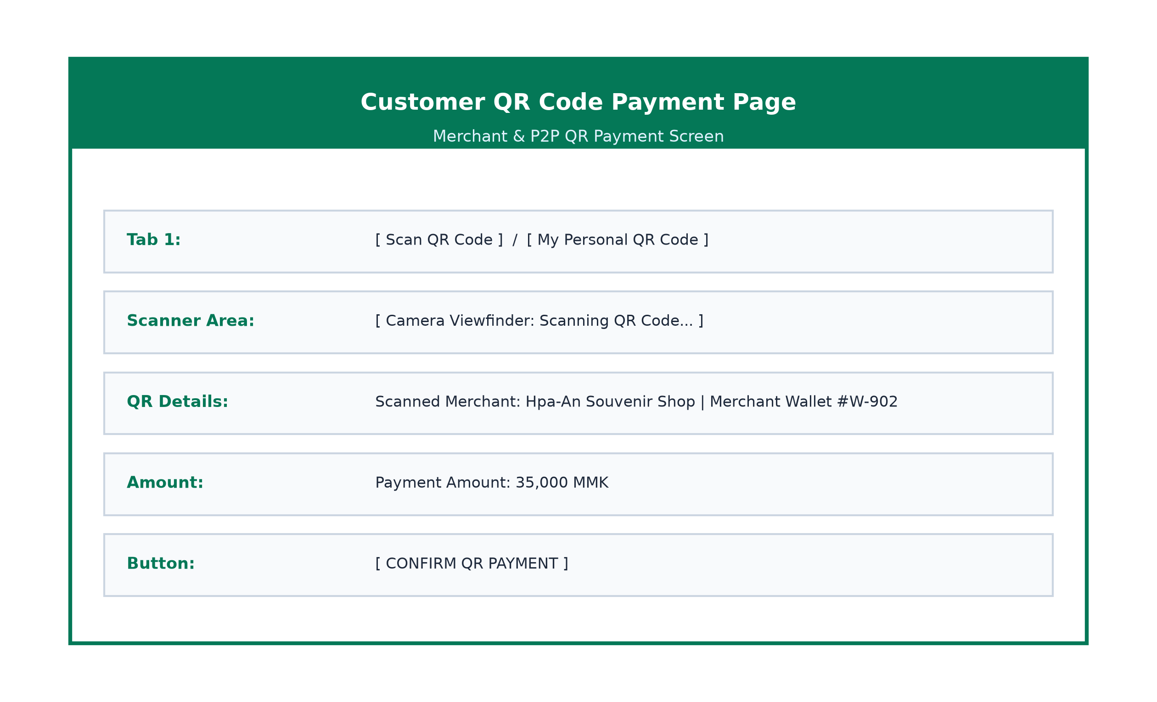
Figure(3.13): Customer QR Code Payment Page

Customer Cash-In / Cash-Out Page
In Figure(3.14), customers locate nearby registered agents to deposit cash (Cash-In) or generate one-time 6-digit withdrawal authorization tokens to receive physical currency (Cash-Out).
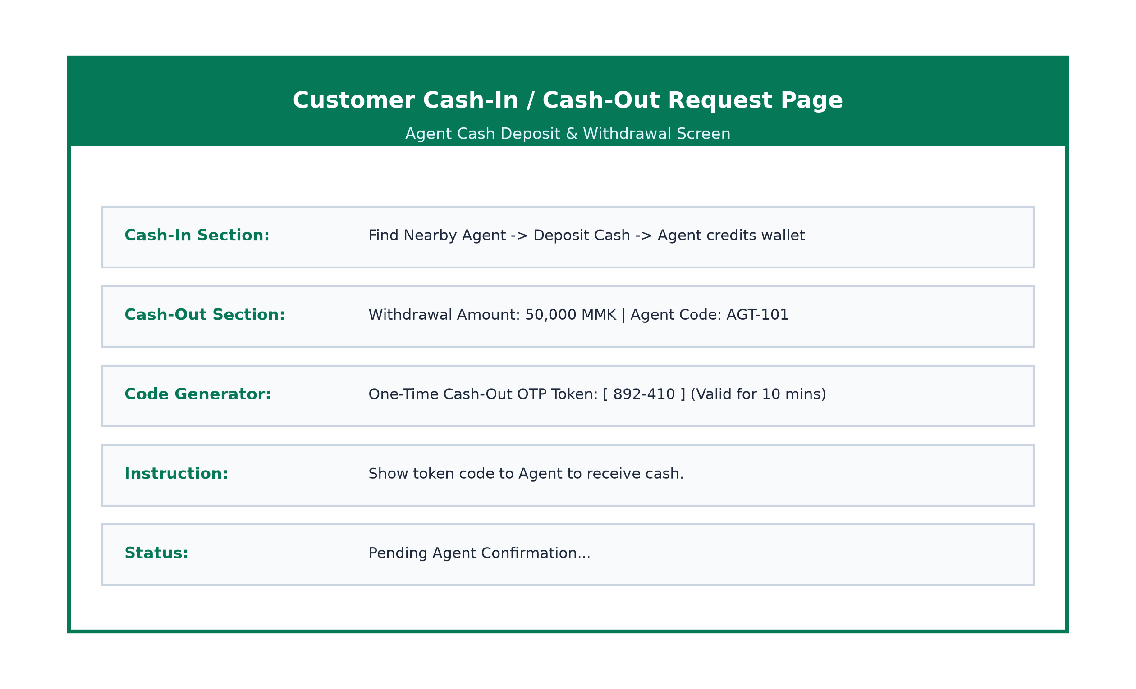
Figure(3.14): Customer Cash-In / Cash-Out Page

Customer NRC KYC Upload Page
In Figure(3.15), customers submit their National Registration Card (NRC) details, state/township location, and photos of front and back NRC cards to upgrade their wallet verification status.
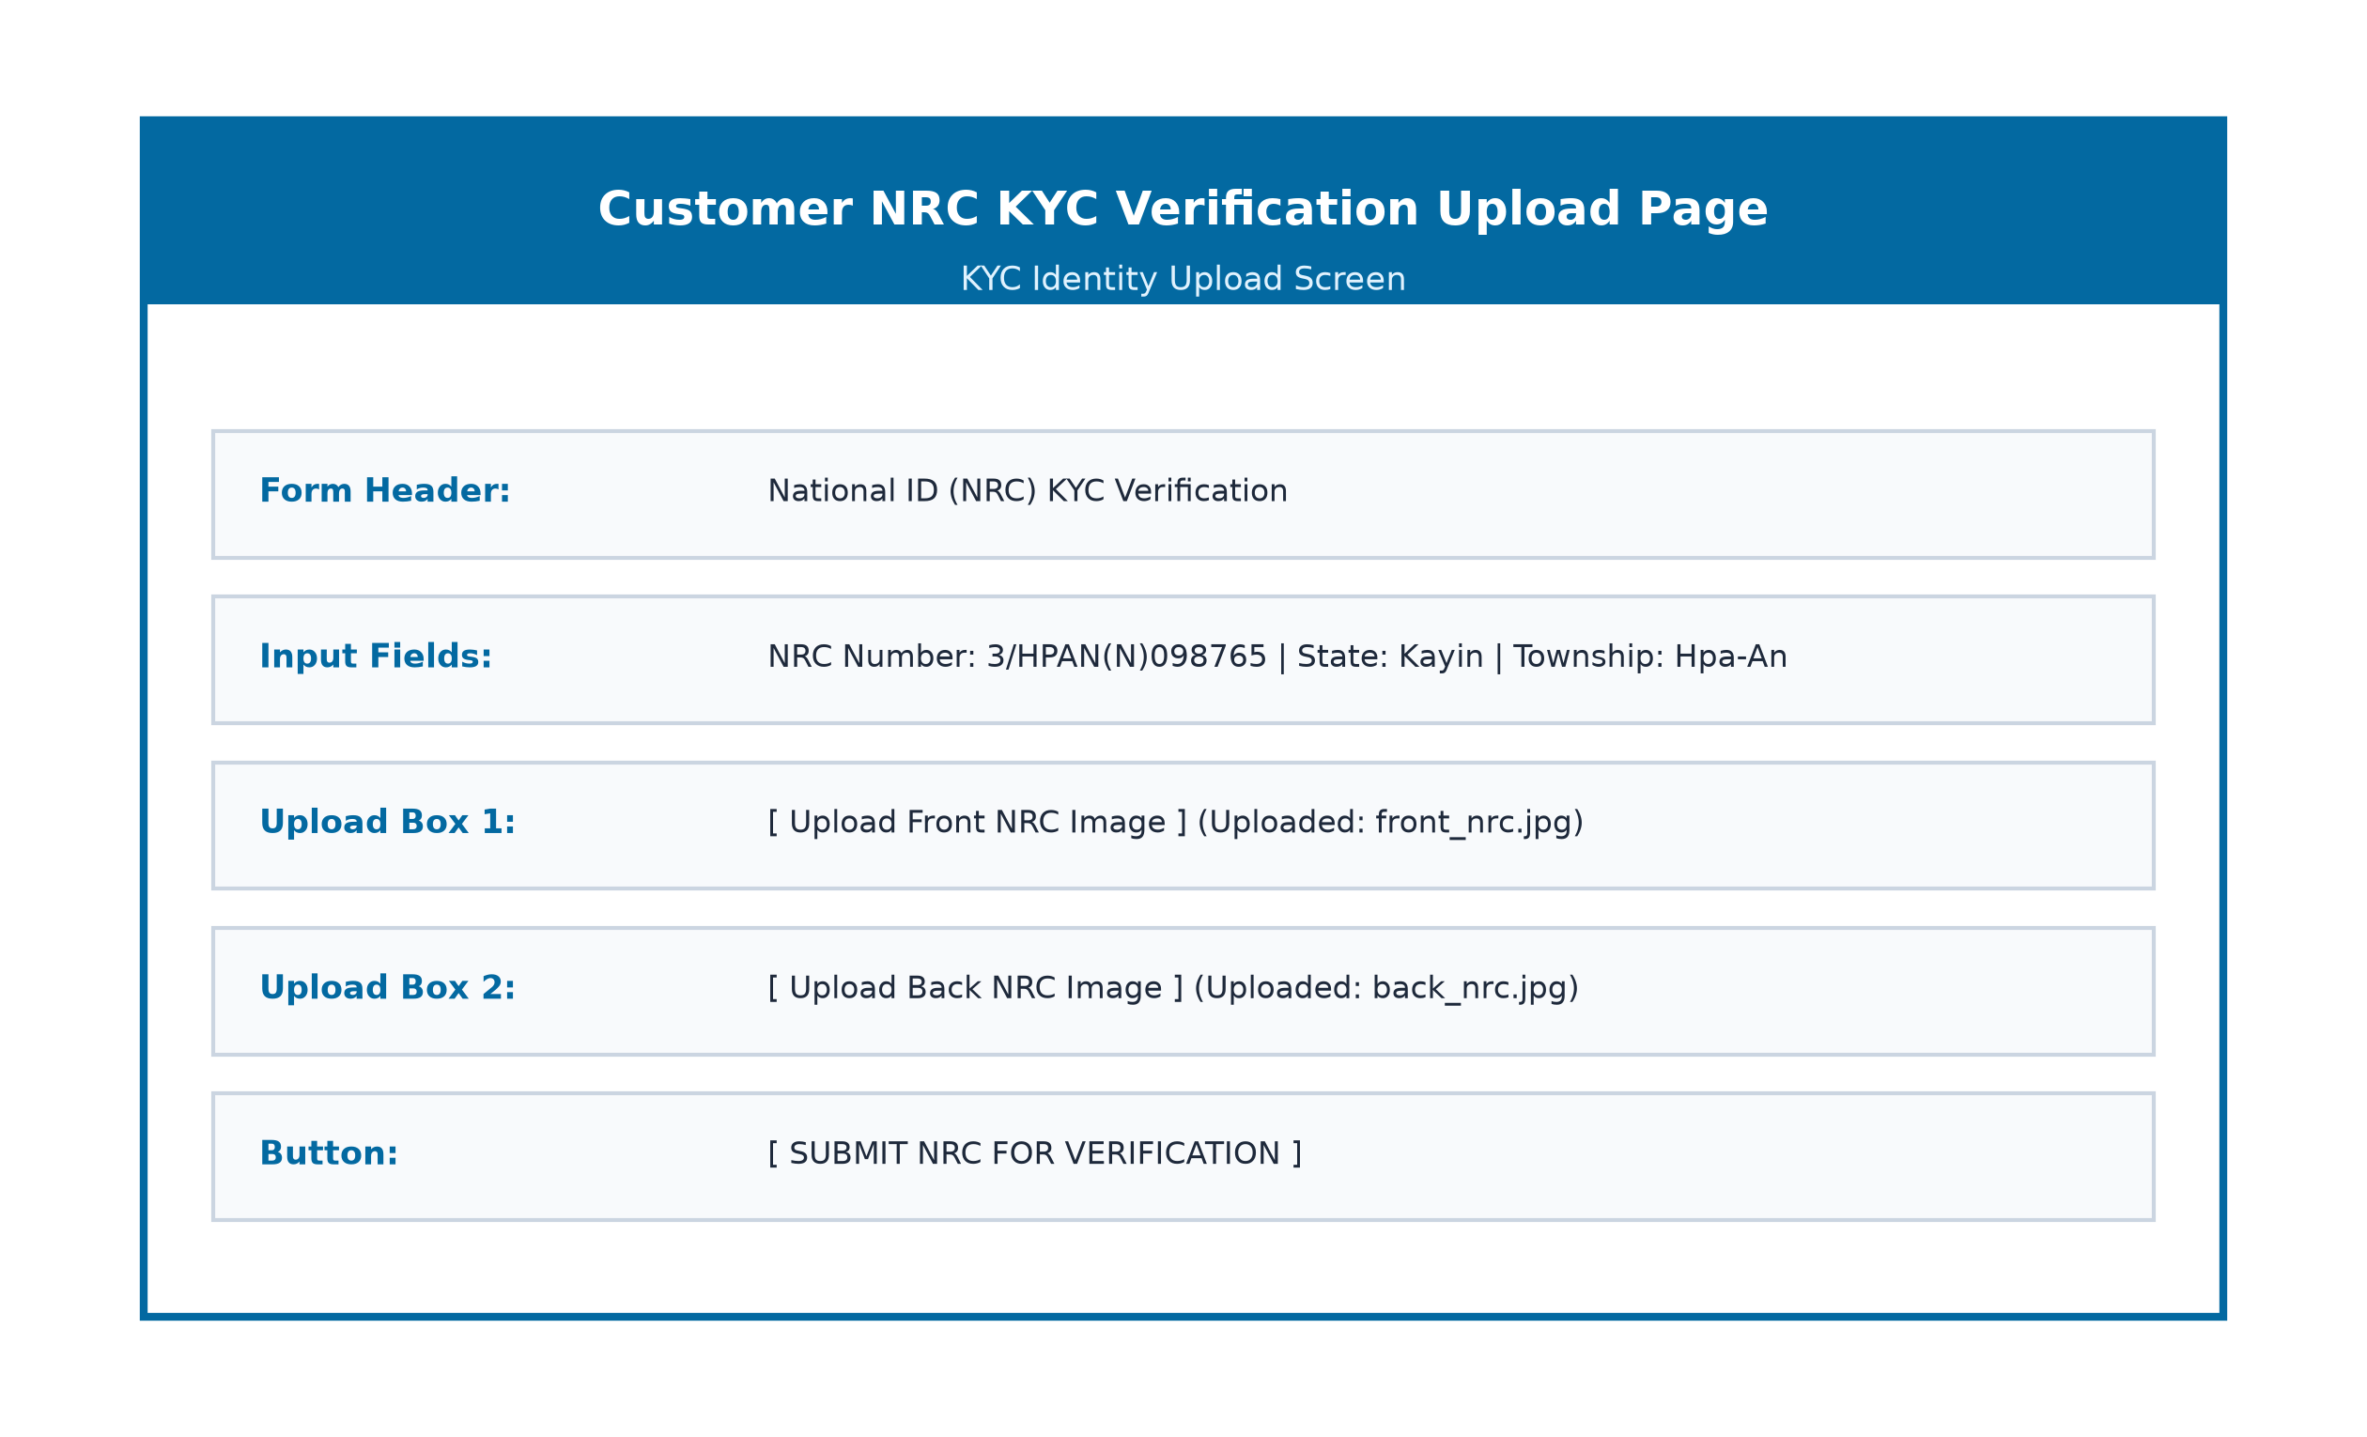
Figure(3.15): Customer NRC KYC Upload Page

Customer Transaction History Page
In Figure(3.16), customers view a comprehensive ledger of all historical wallet credits and debits, filtered by category, with full digital receipt popups.
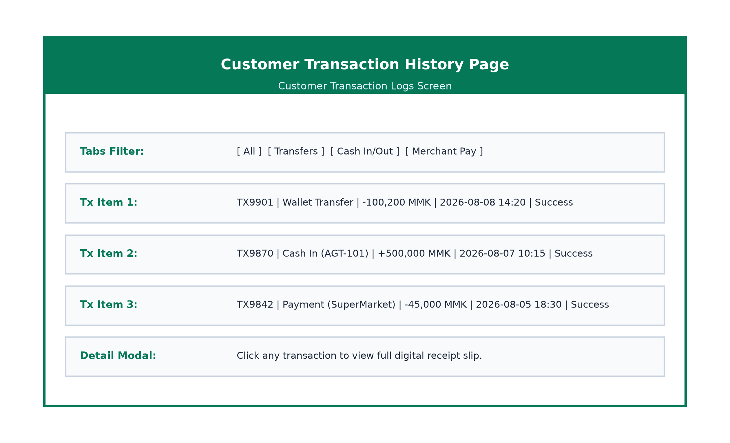
Figure(3.16): Customer Transaction History Page

Agent Sign In & Dashboard Page
In Figure(3.17), financial agents sign into their dedicated agent portal to view real-time float balances, daily Cash-In/Out processing totals, and earned commission summary statistics.
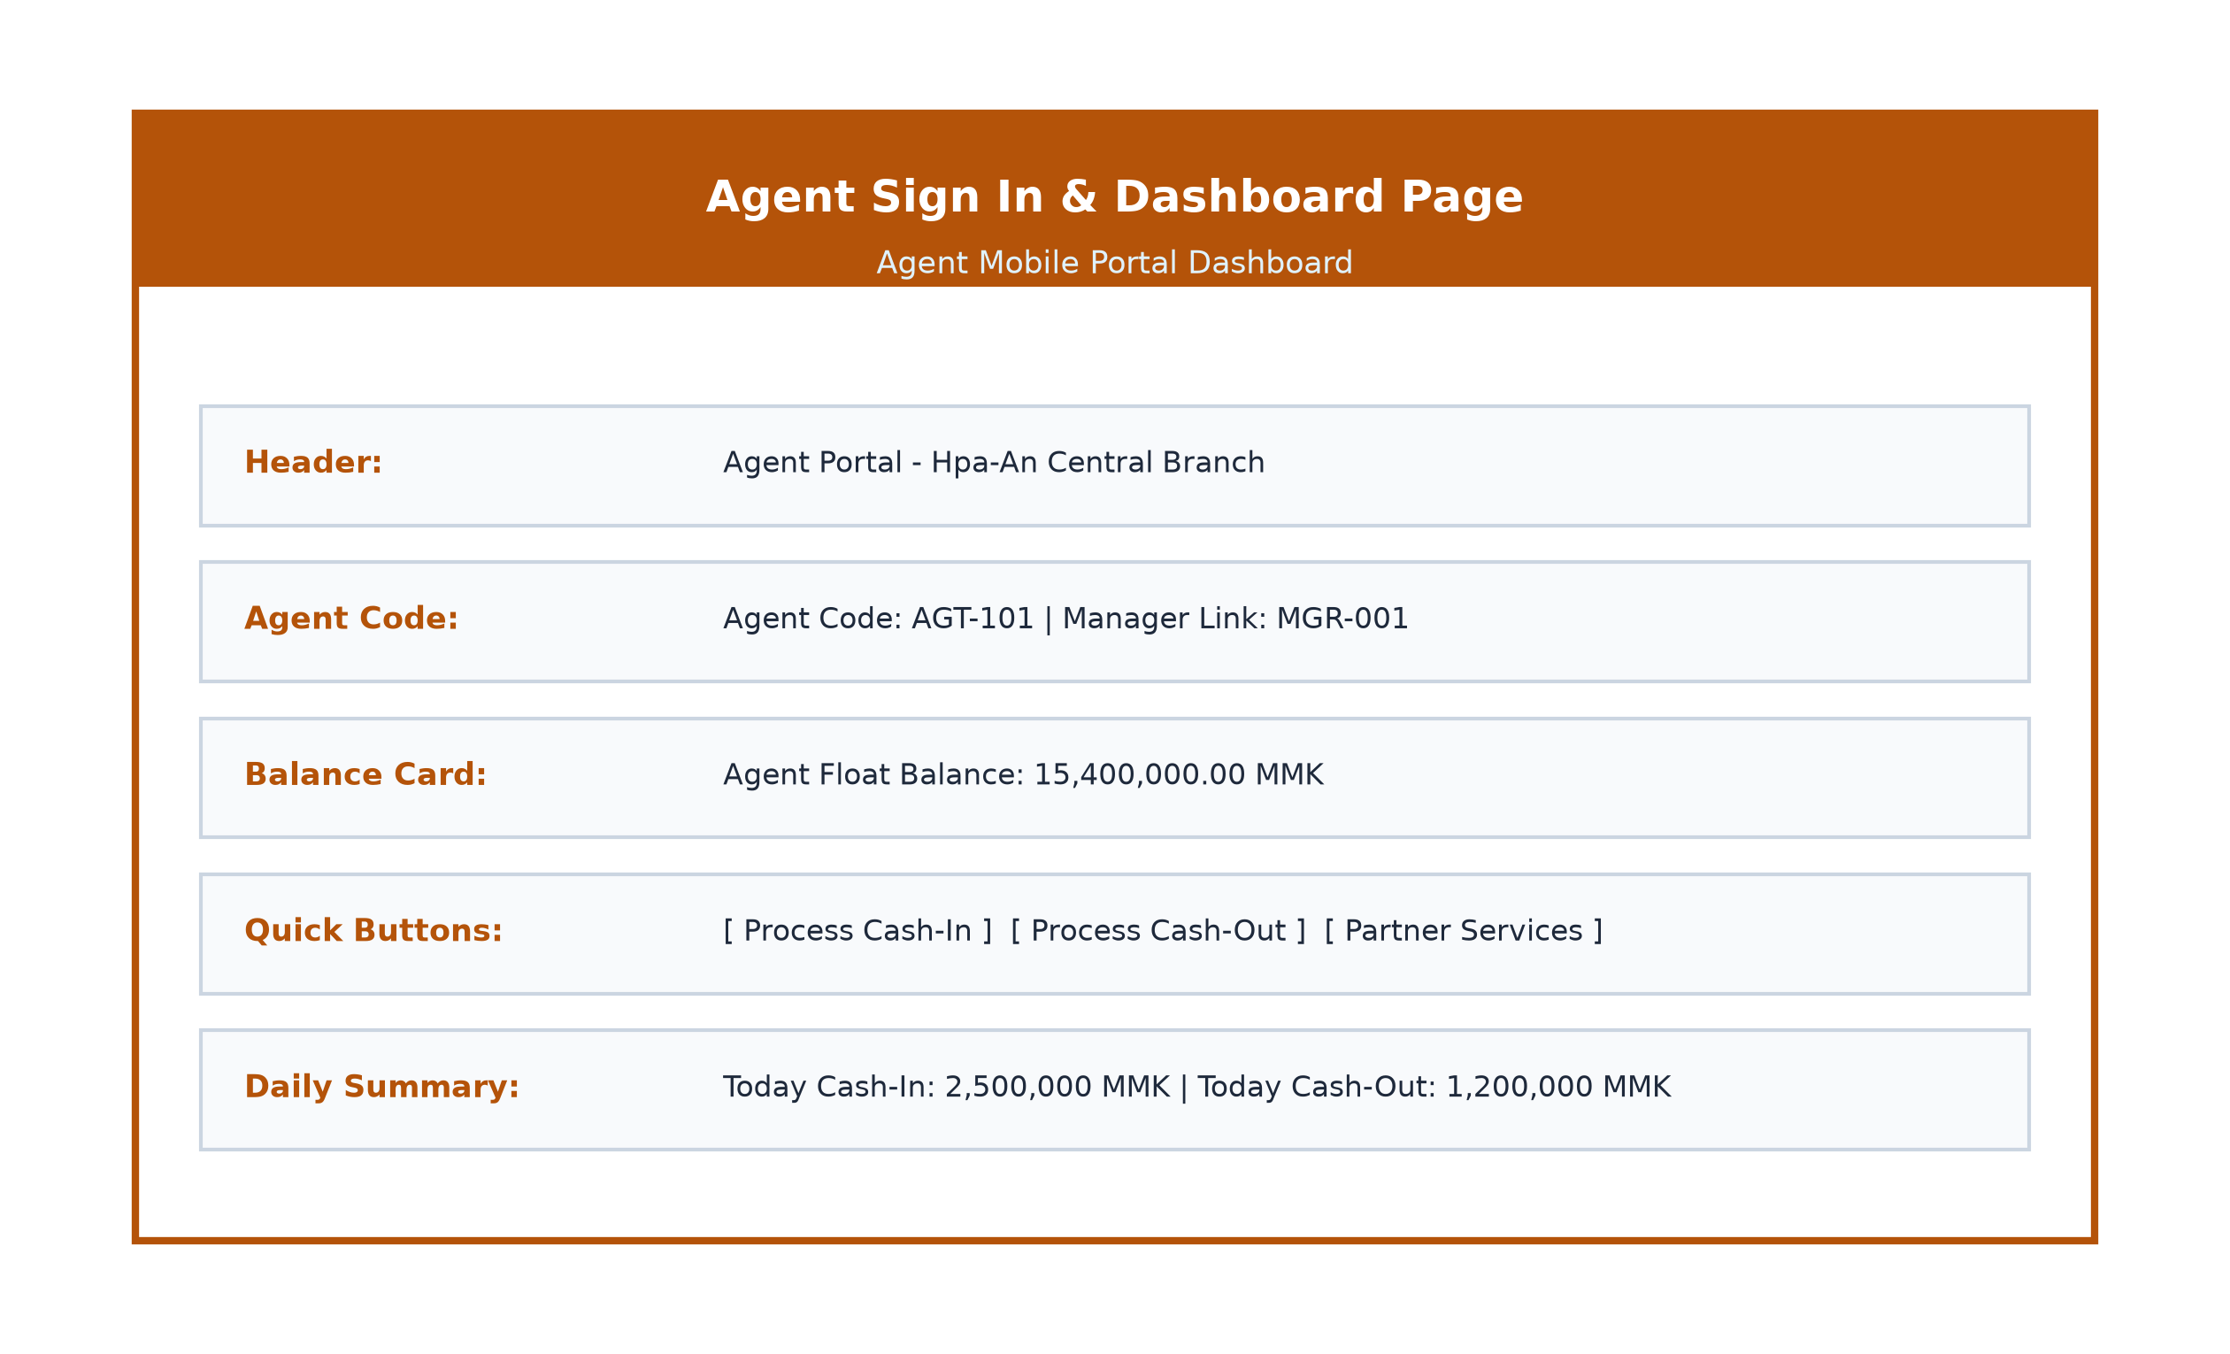
Figure(3.17): Agent Sign In & Dashboard Page

Agent Cash-In Processing Page
In Figure(3.18), agents process customer cash deposits. The agent enters the customer's phone number, verifies the customer name, enters deposit amount and agent PIN, and instantly credits the customer wallet.
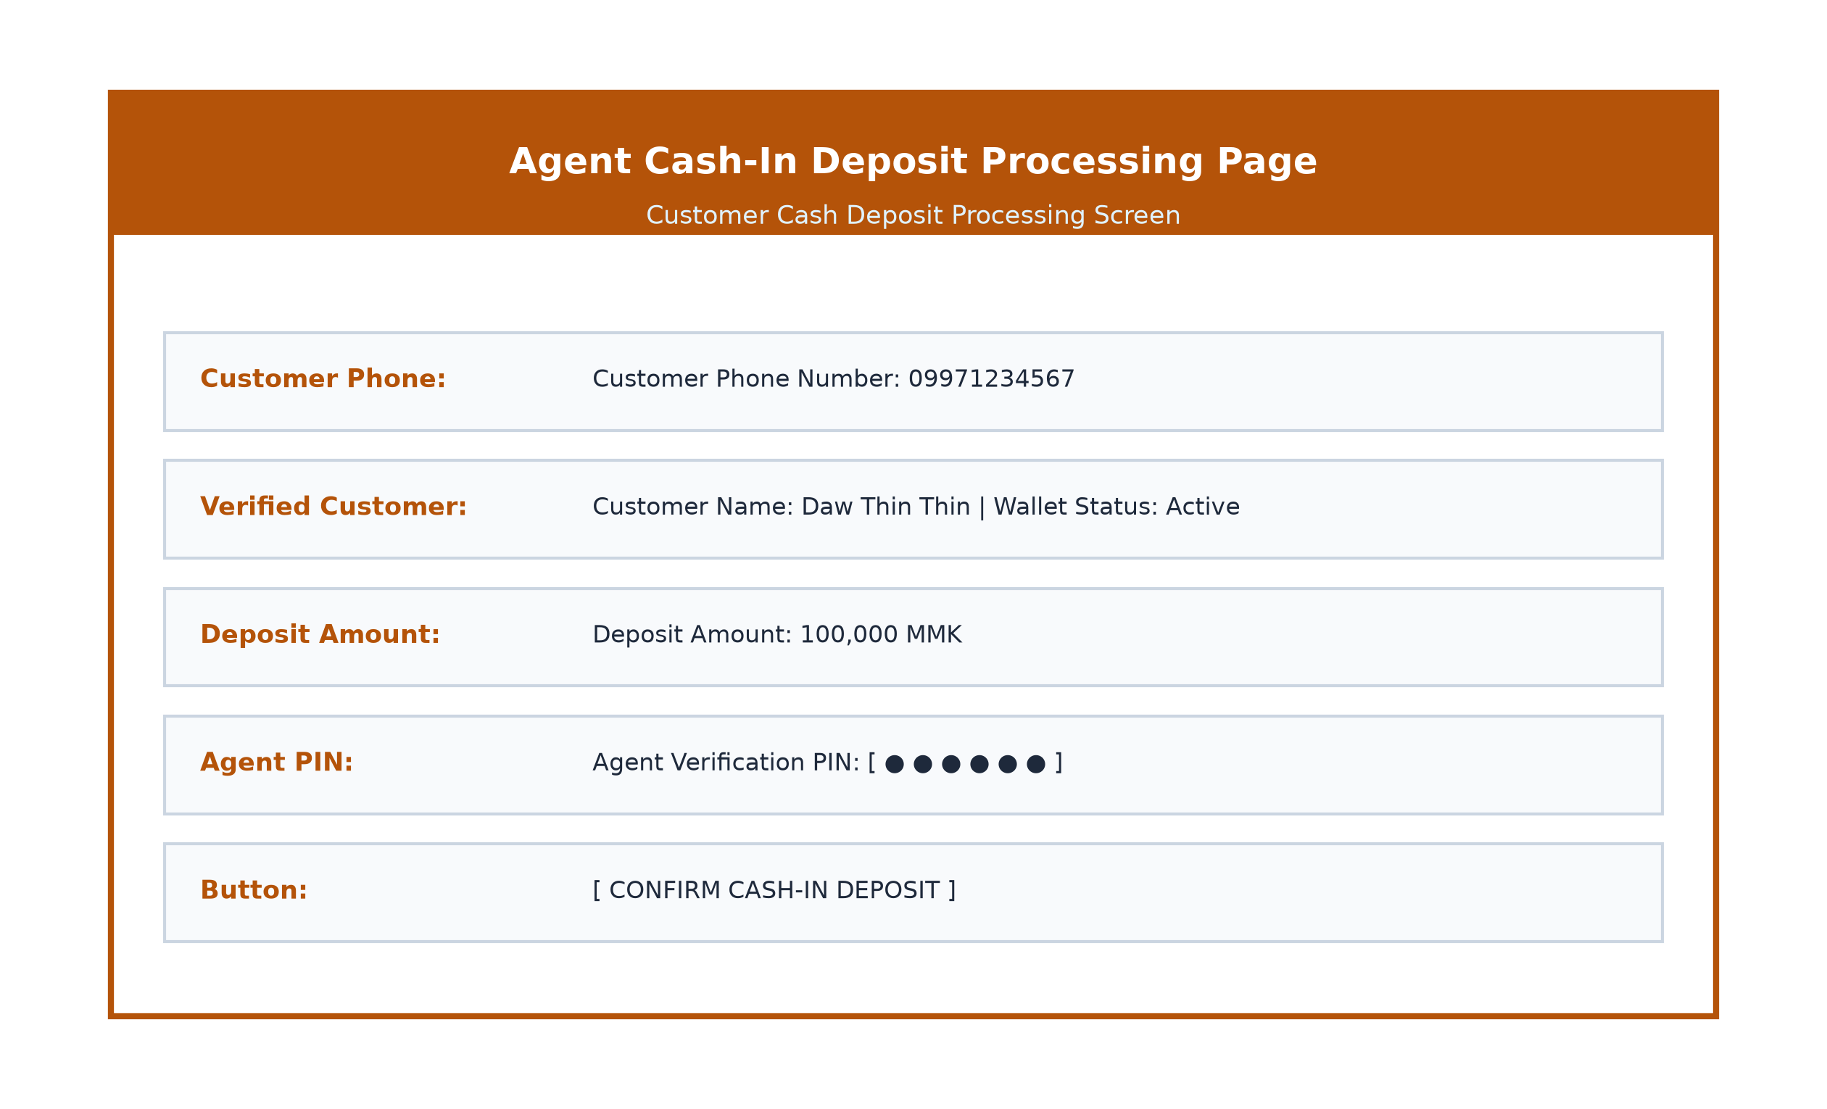
Figure(3.18): Agent Cash-In Processing Page

Agent Cash-Out Processing Page
In Figure(3.19), agents fulfill customer cash withdrawal requests by verifying the customer's 6-digit cash-out token, validating the withdrawal amount, entering the agent PIN, and handing over physical cash.
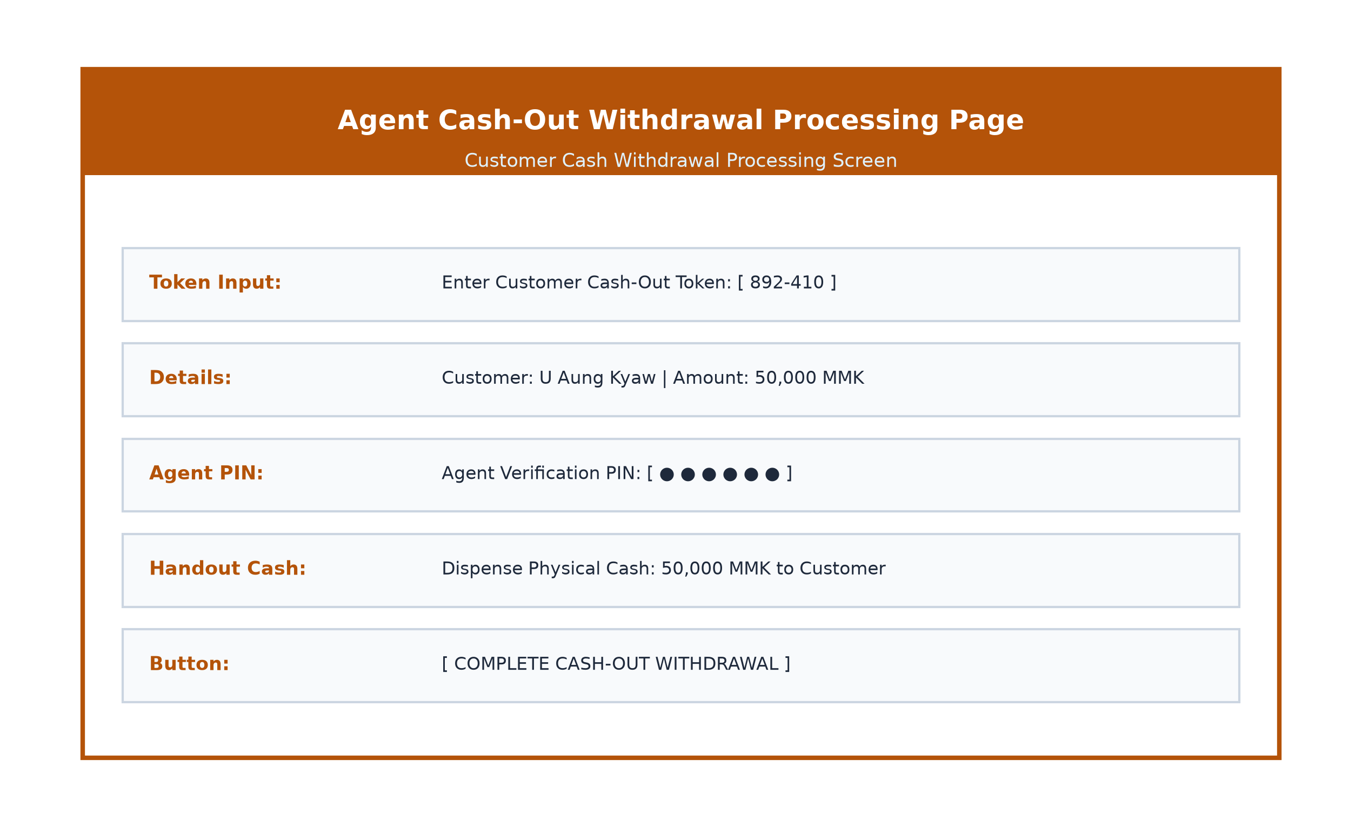
Figure(3.19): Agent Cash-Out Processing Page

Agent Partner Services Page
In Figure(3.20), agents manage partner merchant integrations and e-commerce payment gateways, allowing them to issue new API keys for connected local businesses.
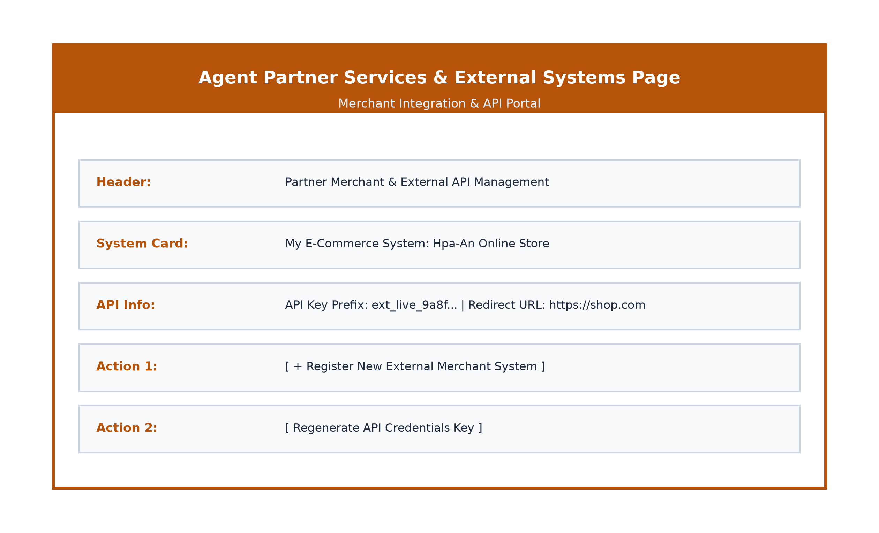
Figure(3.20): Agent Partner Services Page

Agent Transaction History Page
In Figure(3.21), agents view daily financial cash flow statements, auditing total deposits processed, withdrawals fulfilled, and cumulative agent commission earnings.
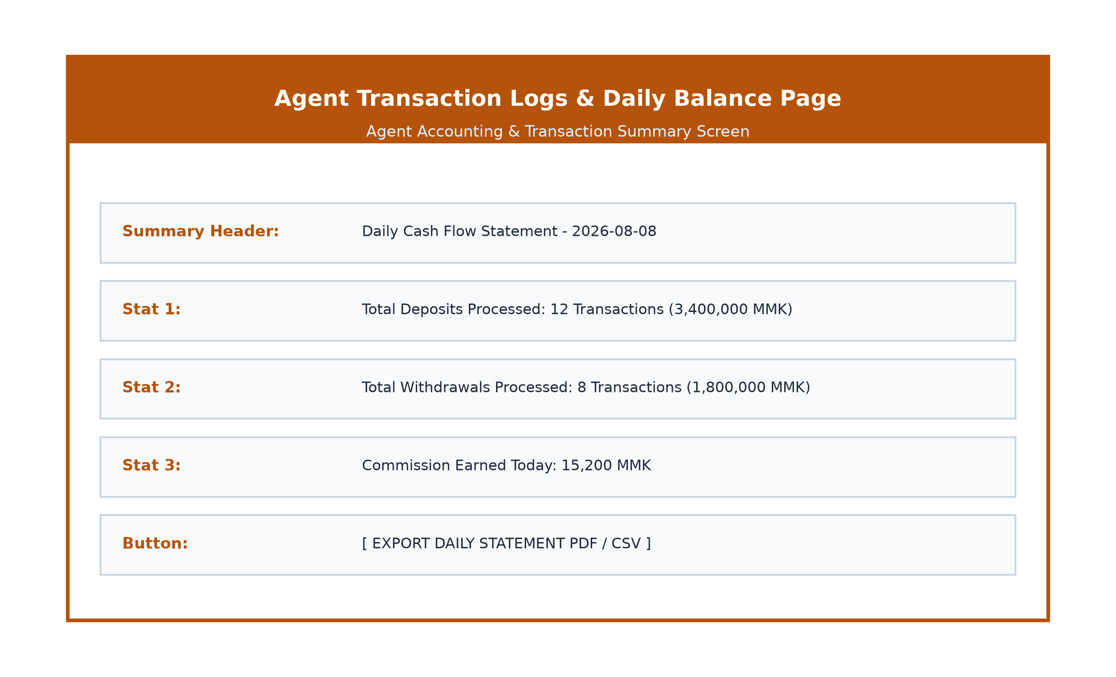
Figure(3.21): Agent Transaction History Page

Chapter (4)

4.1 Conclusion
The Digital Wallet Management System successfully addresses the operational bottlenecks, security risks, and accessibility limitations of traditional cash-based transactions in Myanmar. By delivering a modern, centralized fintech infrastructure, the system enables individual consumers, financial agents, and retail merchants to conduct instant, secure electronic payments.
Key technical achievements of the project include:
• High Security & Fraud Prevention: Integration of phone OTP validation, Bcrypt 6-digit PIN hashing, rate-limiting middleware, and NRC document verification guarantees user account integrity.
• Scalable Architecture: Implementation of a decoupled RESTful API backend using Laravel PHP and PostgreSQL, serving multi-platform frontend web and mobile clients seamlessly.
• Financial Agent Ecosystem: Facilitation of liquidity hubs allowing unbanked users to exchange cash for digital balances easily.
• E-Commerce Gateway Readiness: Provision of external merchant system key management enabling automated payment processing for local businesses.
Future enhancements will focus on integrating artificial intelligence for automated fraud detection, implementing biometric facial recognition for KYC approval, adding multi-currency support, and expanding utility bill payment integrations.

REFERENCES
PHP Documentation. Available at: https://www.php.net/docs.php
Laravel 11 Framework Documentation. Available at: https://laravel.com/docs/11.x
PostgreSQL Relational Database Documentation. Available at: https://www.postgresql.org/docs/
React Native & Expo Documentation. Available at: https://docs.expo.dev/
React & Vite Web Framework Documentation. Available at: https://react.dev/
Central Bank of Myanmar Mobile Financial Services Regulations. Available at: https://www.cbm.gov.mm/
Mozilla Developer Network (MDN) Web & Security Docs. Available at: https://developer.mozilla.org/
OWASP Mobile & REST API Security Top 10 Guidelines. Available at: https://owasp.org/www-project-api-security/

